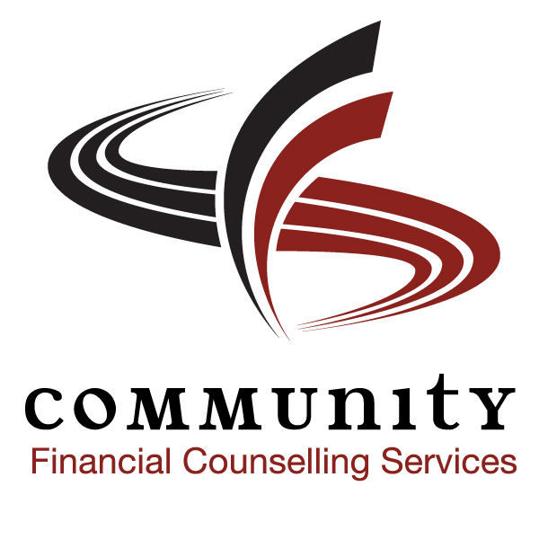
COMMUNITY ADVOCATES CONFERENCE
C a p a c I t y B u i l d i n g f o r A d v o c a t e s
TUESDAY, OCTOBER 30TH, 2012
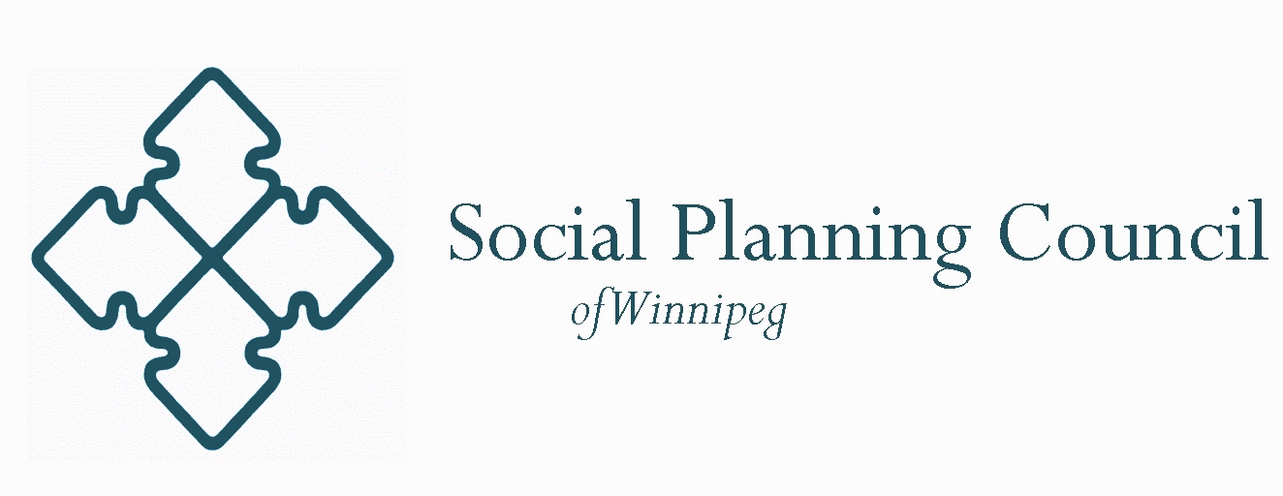
Presentations/Workshops

Media Relations
Media Relations will include topics such as: preparing advocates and participants to engage with the media, tips on how to speak to the media, developing relationships with the media, and what is newsworthy.
Mediation and Alternative Dispute Resolution
Interest is growing in looking at alternative ways of resolving disputes, including mediation. Many government programs and services are offering mediation as an alternative to traditional administrative tribunals. This presentation/workshop will provide information on mediation and ADR for those who are interested in new and emerging alternatives to more adversarial models.
Navigating through Government
Navigating through Government will assist advocates in dealing with government structures from bureaucracy and politicians. It will also help to understand who and when to contact the levels of government when working with a participant.
Understanding Administrative Tribunals
Understanding Administrative Tribunals will provide advocates with a better understanding of the composition, role, function, and processes of administrative tribunals such as the Board of Referees (Employment Insurance), Social Services Appeal Board (Employment and Income Assistance), and Human Rights Commission.
You and the Client/Participant
This presentation/workshop will help you to better assist your clients/participants effectively. Topics of discussion will include: fact-finding, communication, privacy and confidentiality, preparing for a hearing, and case management.
Mental Health Accommodation
Advocates attending Mental Health Accommodation will leave with knowledge on how to properly help those who are dealing with mental health problems in relation to Human Rights violations/concerns.

Community Unemployed Help Centre, Public Interest Law Centre of Legal Aid Manitoba, Community Financial Counseling Services, and West Central Women’s Resource Centre held a conference in 2009 that was attended by over 120 community-based advocates. This conference offered educational presentations, workshops, and panel discussions to provide advocacy tools to participants with a full day of information, networking and motivation.
On October 30th, 2012, CUHC, PILC of LAM, CFCS, Social Planning Council of Winnipeg, and New Directions will be holding a second full-day conference titled “Community Advocates Conference – Capacity Building for Advocates.” This conference will provide participants with similar tools as the conference held in 2009 and will help build skills and competencies for those interested in various forms of advocacy.

CUPE 2348

